**Student Name: *YASH_GUPTA***

**UID: *20BCS5009***

**Date of Performance:*08/10/20***

**Branch: *CSE*  Section/Group: CSE 34 B**

**Subject Name: *Electronics’***

## **Aim**

Design a pulse width modulated signals generator using 555.

## **Task to be done**

To make 555 Timer PWM Generator Circuit

## **Requirements**

Wires , Breadboard ,Power , Capacitor, Resistors

## **Circuit diagram**

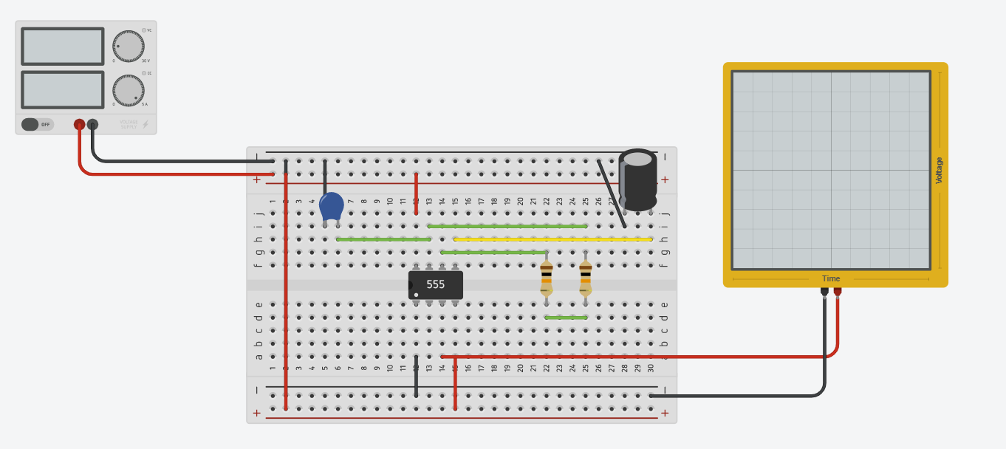

## **Simulation Results:**

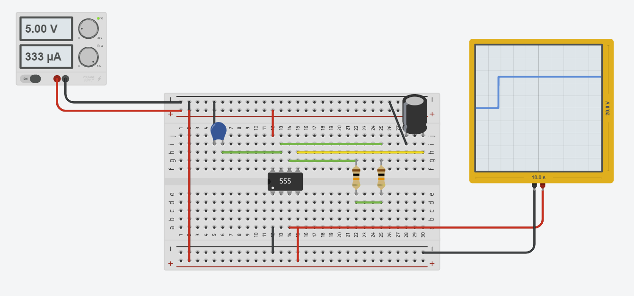

## **Concept used**

## **Learning**

***The use of 555 Timer PWM Circuit***

## **Troubleshooting**